Contributions:

* Anish Kshatriya: Coding
* Lynn Wall: Graphic Design

**Aroy~Thai**

Aroy~Thai is a website that promotes Thai culture. The focus of the website, however, is Thai food. In addition, there are recipes available for Thailand’s most popular dishes. We also provide the locations and details to nearby Thai restaurants. Finally, we feature a well-known Thai restaurant in the heart of Thailand: Bangkok.

In terms of making revenue, we will have affiliate programs with the restaurants we plan to advertise and promote, advertise Asian supermarkets and/or stores where the ingredients are available to be purchased, advertise websites where consumers are able to purchase airline tickets to Thailand, and where they can book hotels in Thailand. The only revenue that will be generated from this website is from advertisements. One of the basic formulas that we will use to calculate how much it cost to advertise on our website is:

Total earn = CPM x (Total Impressions/1,000)

*The rate of CPM can range from $0.1 up to $20 or more

We will be using Google AdWords to bid on keywords such as “thai food” and “thai recipes”. The suggested big for “thai food” is $1.71 and for “thai food recipes” its $0.58. Respectively, the average monthly searches are 1,900 and 170 and plan to bid $2.00 and $0.75.

We will use pay per clicks method instead of pay for impressions to advertise our website because we want people to click and visit our website. The more traffic to our website is the better because we want people to see the ads that are on the website and the information about Thai food in order for the website to generated revenue.

Design File Link:

<http://mywebclass.org/~ak557/117/design/>

**Website screen shots**

Home Page

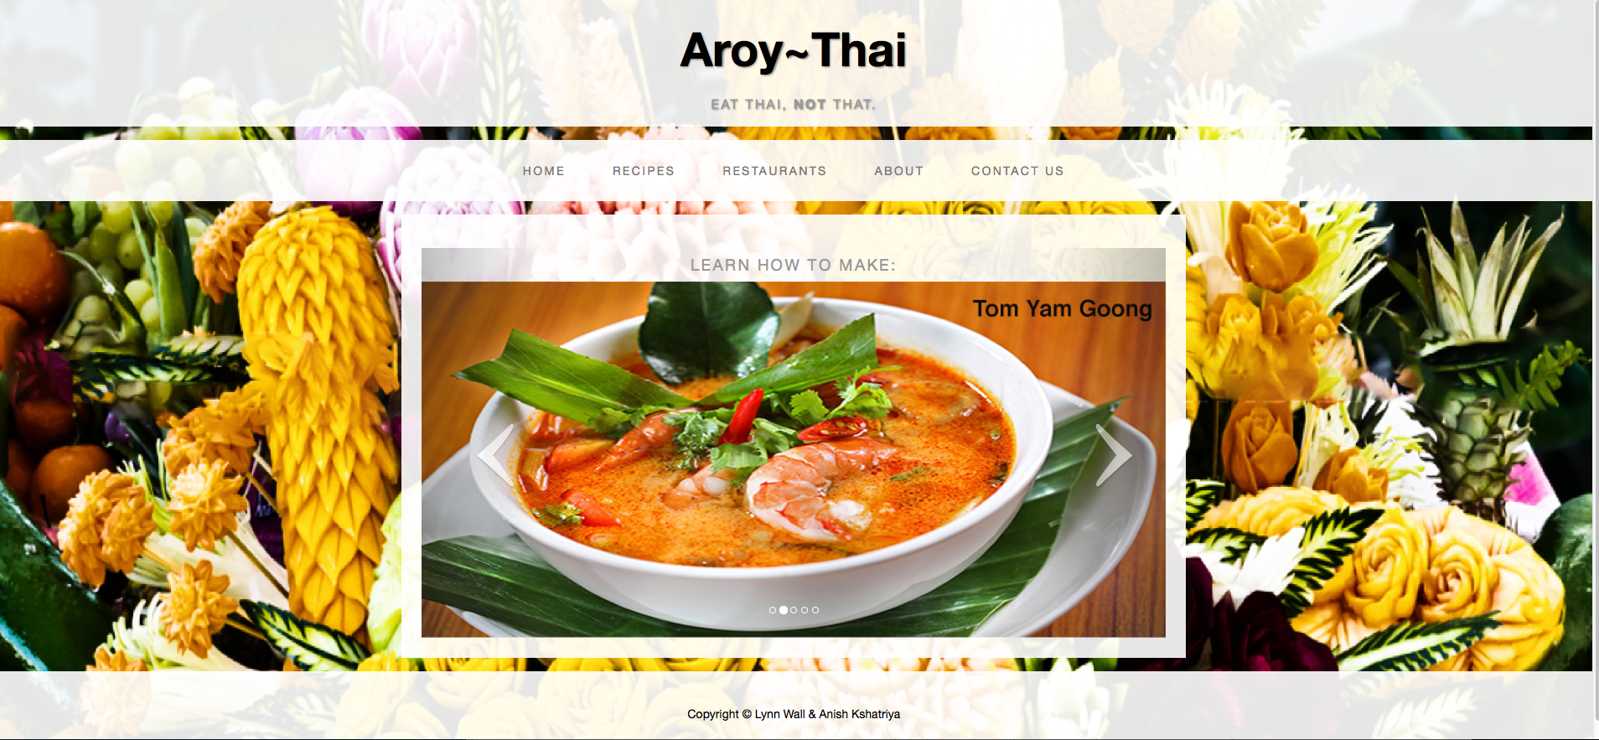

Recipes page

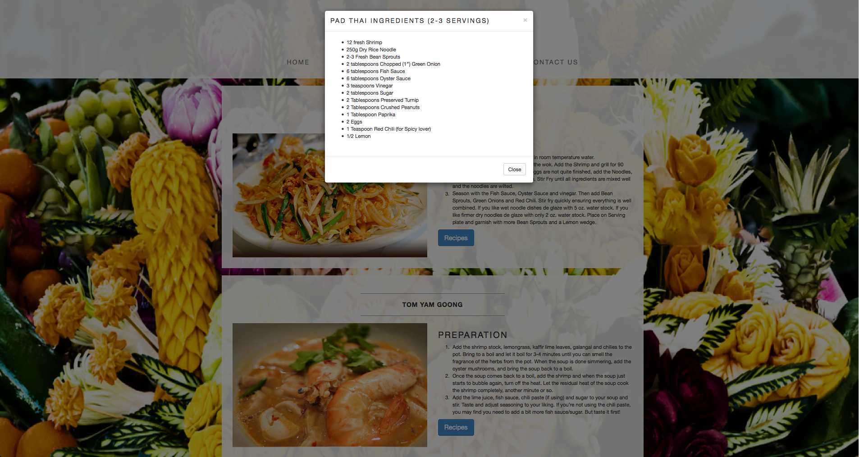

Restaurants page

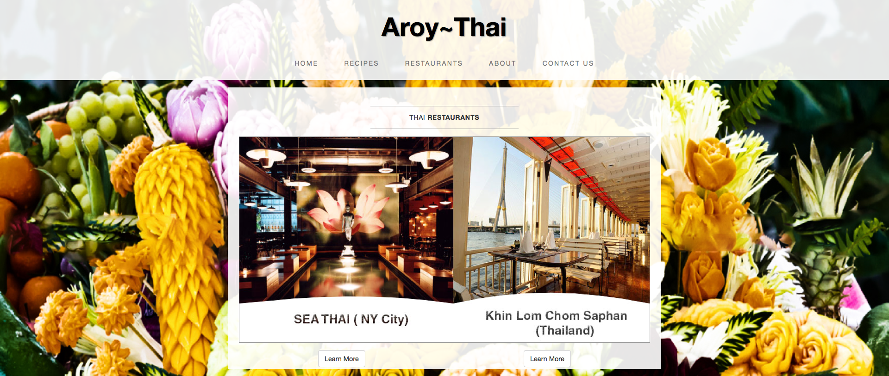

About Us Page

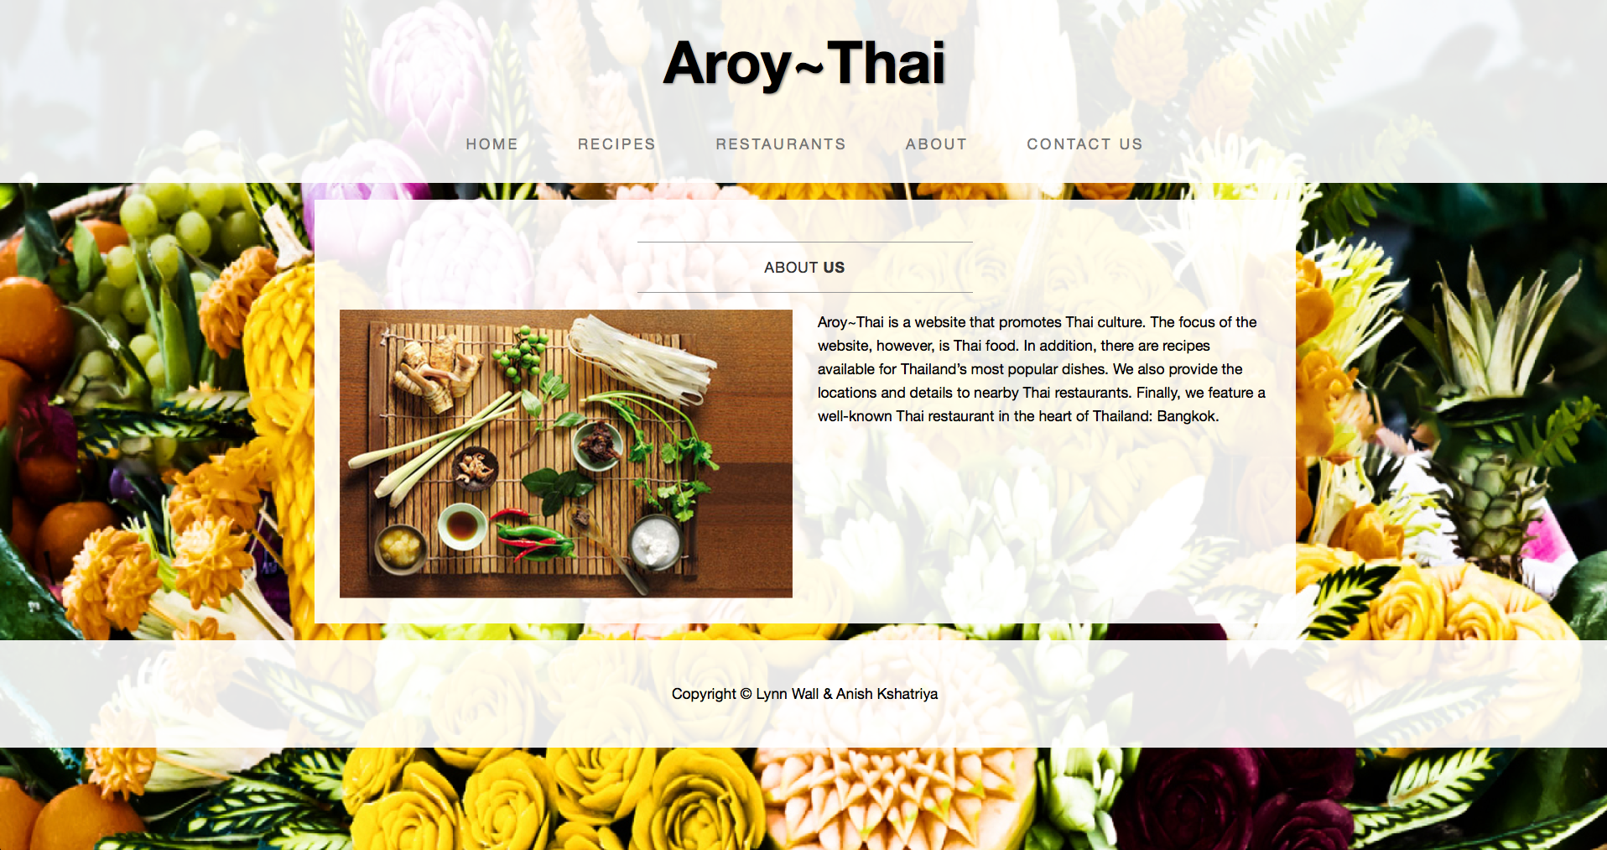

Contact page

